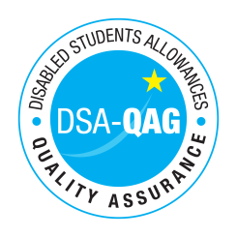
Individual Assessments – Alison Davies - NMH Rates

Period covered - 01/12/2018 through to 31/03/2019

The table below shows NMH rates. The greyed out cells indicate that the NMH provider does not offer these services.

Note: NMH Support Rates shown per hour in the table below.
 | Standard Rate (in-person) |  |  | Distance Learning only (in-person, in-home |  |  | Remote Delivery (e.g. Facetime/Skype or similar) Only
Band 4 Specialist Access and Learning Facilitators | Net | VAT | Total | Net | VAT | Total | Net | VAT | Total
Specialist Mentor – AS | TBC | 0.00 | TBC | TBC | 0.00 | TBC | TBC | 0.00 | TBC
Specialist 1:1 Study Skills Support – SpLD | 40.00 | 0.00 | 40.00 | 60.00 | 0.00 | 60.00 | 40.00 | 0.00 | 40.00
Specialist 1:1 Study Skills Support – AS | 40.00 | 0.00 | 40.00 | 60.00 | 0.00 | 60.00 | 40.00 | 0.00 | 40.00

